**What is OAK?**A tree that bears acorns as fruit, and typically has lobed deciduous leaves.

**What is Java Plug-in ?**The **Java Plug**-**in** software is a component of the **Java** Runtime Environment (JRE). The JRE allows applets written **in** the **Java** programming language to run inside various browsers. The **Java Plug**-**in** software is not a standalone program and cannot be installed separately.

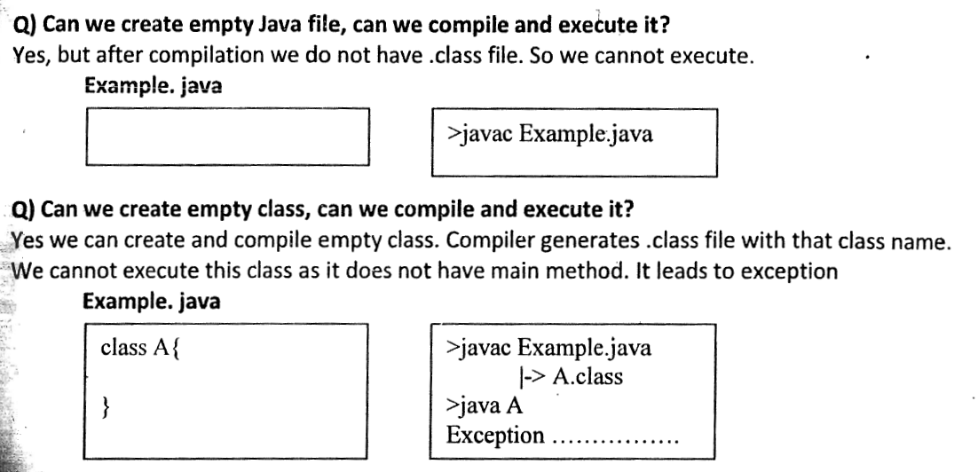

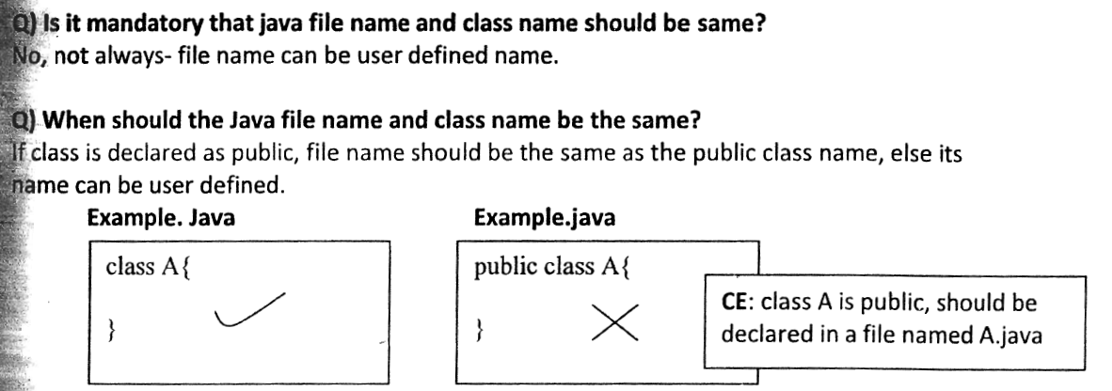

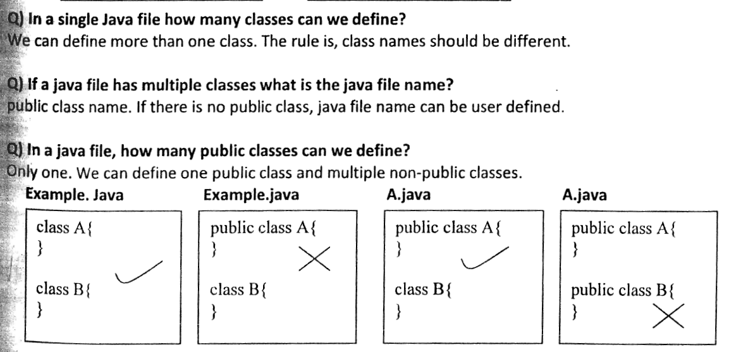

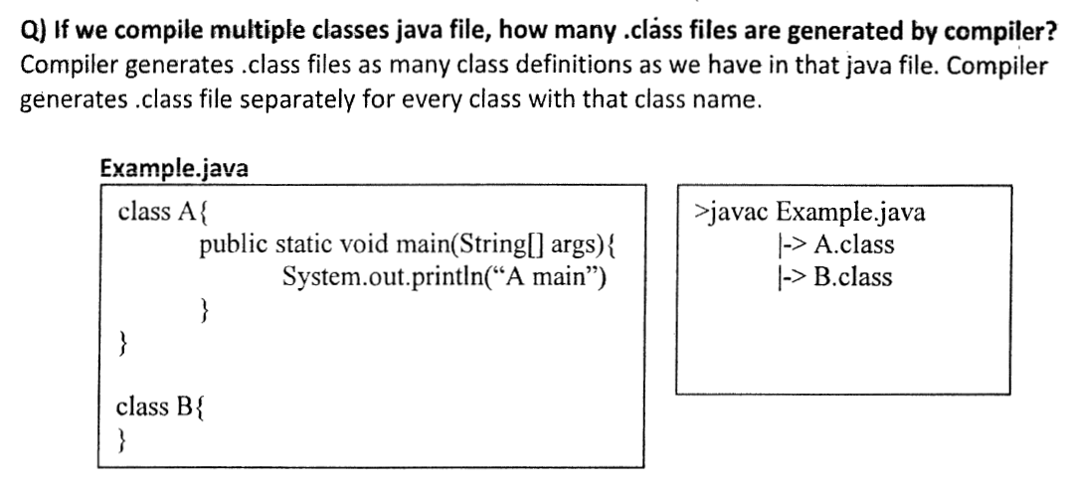

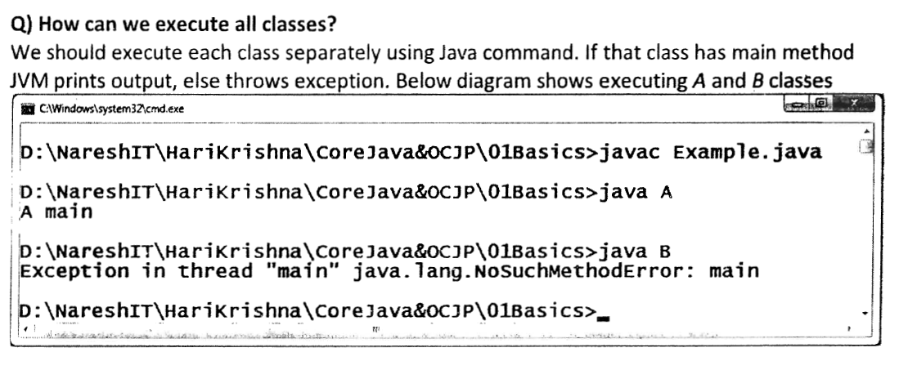

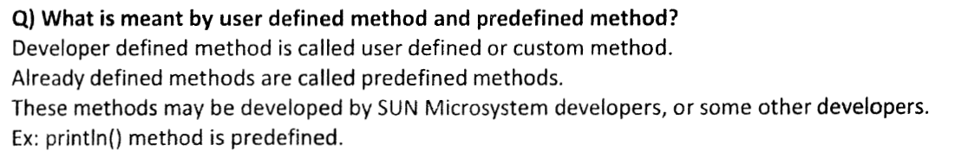

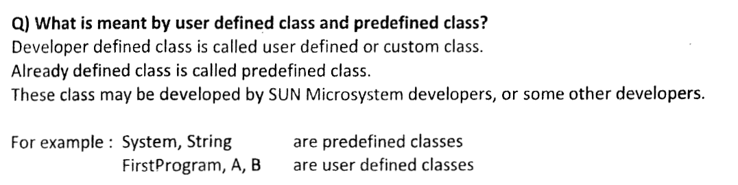



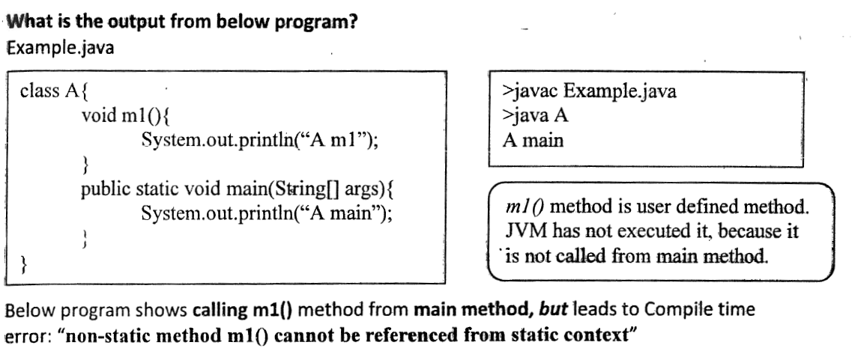

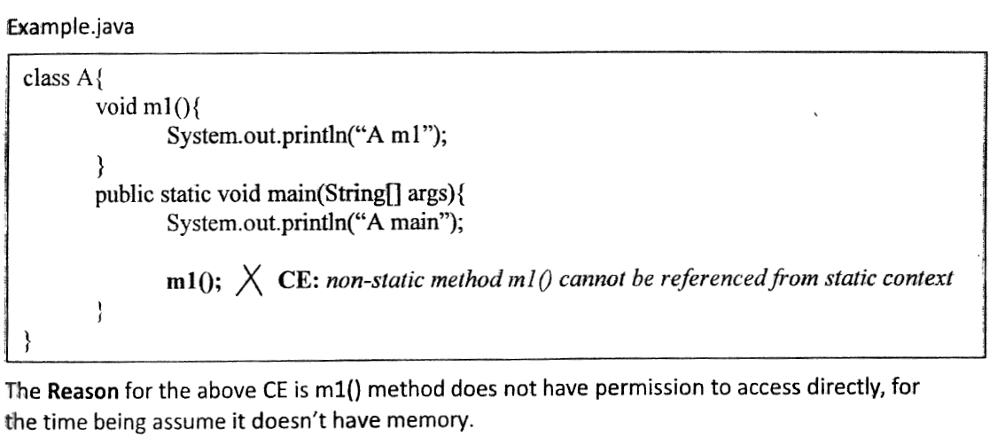

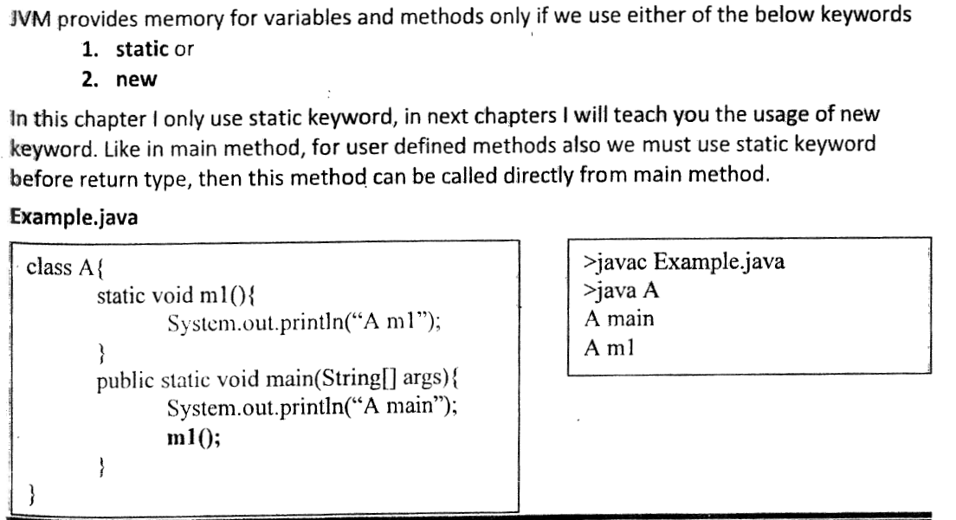

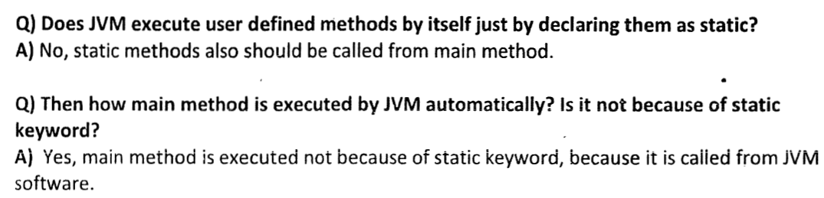

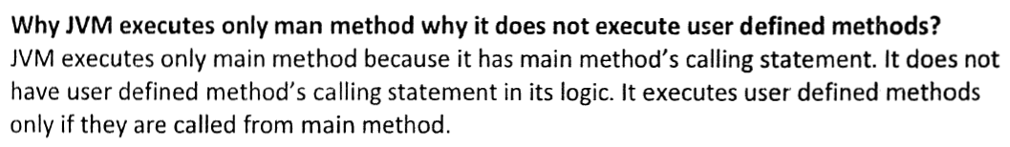

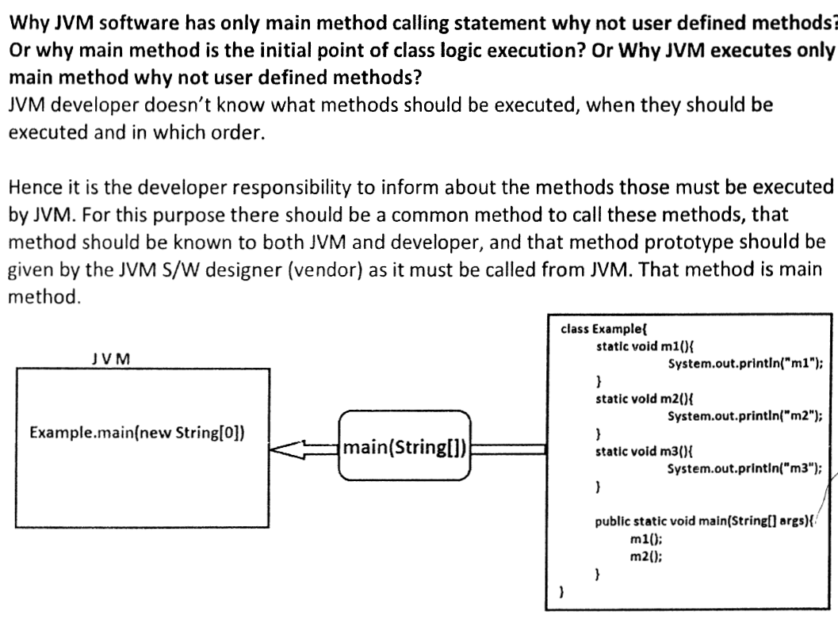

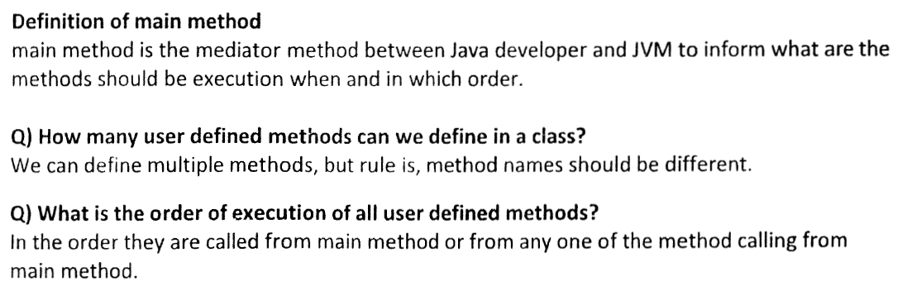

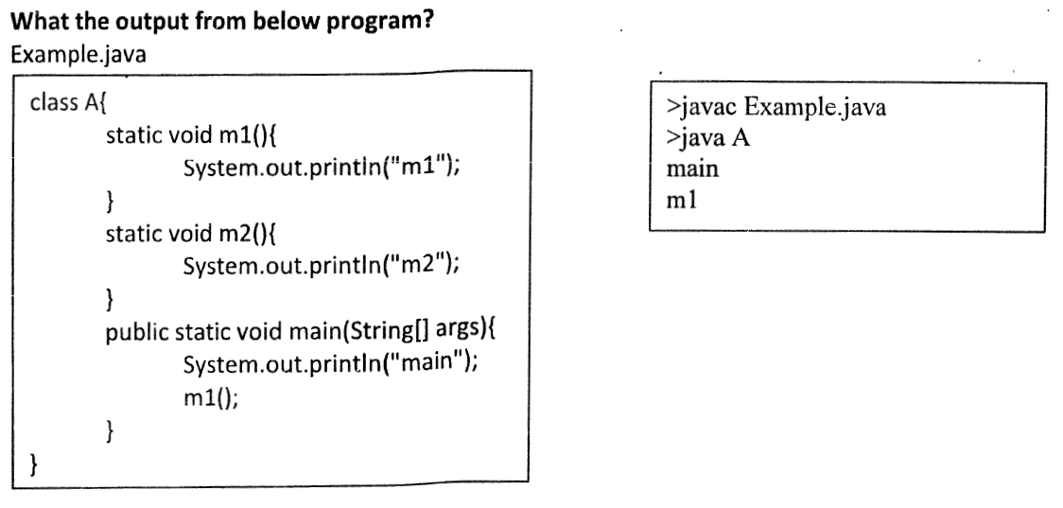

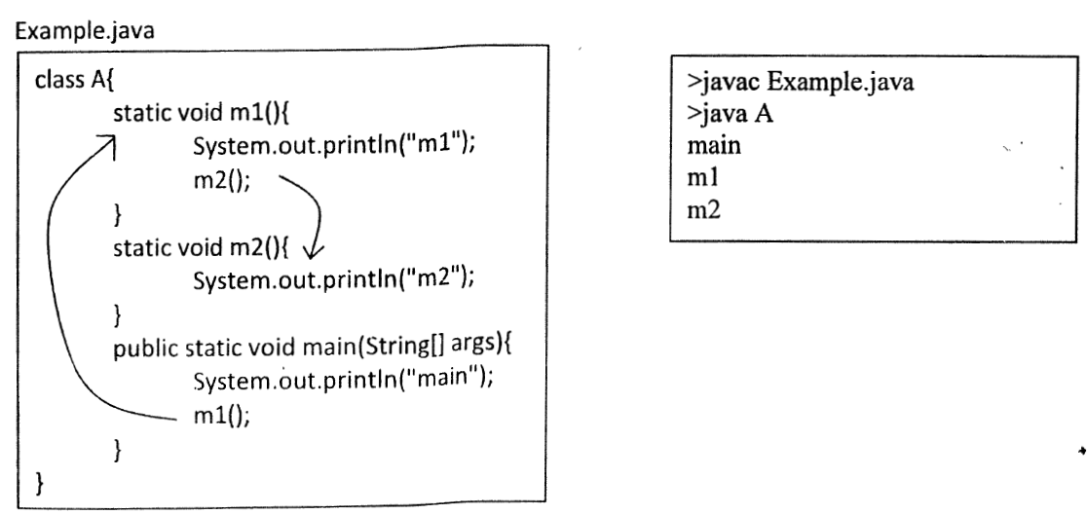

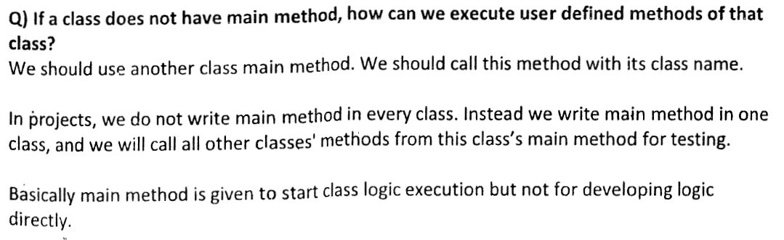

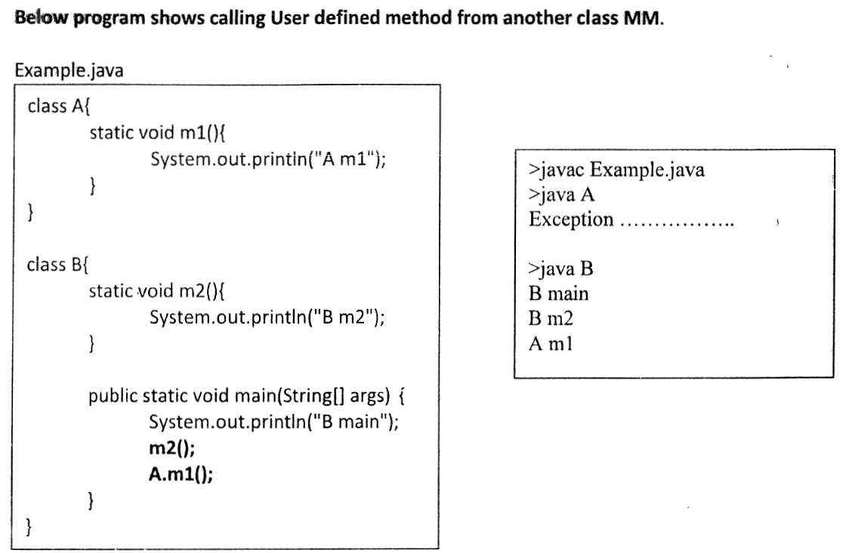

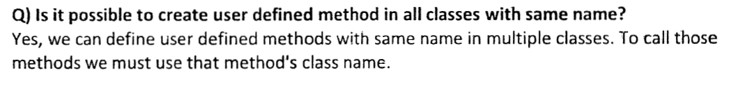

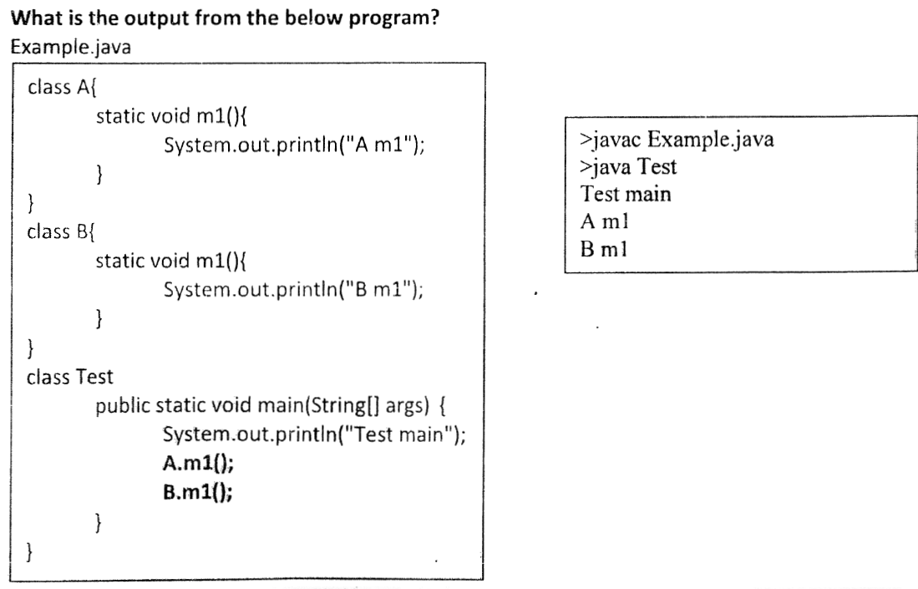

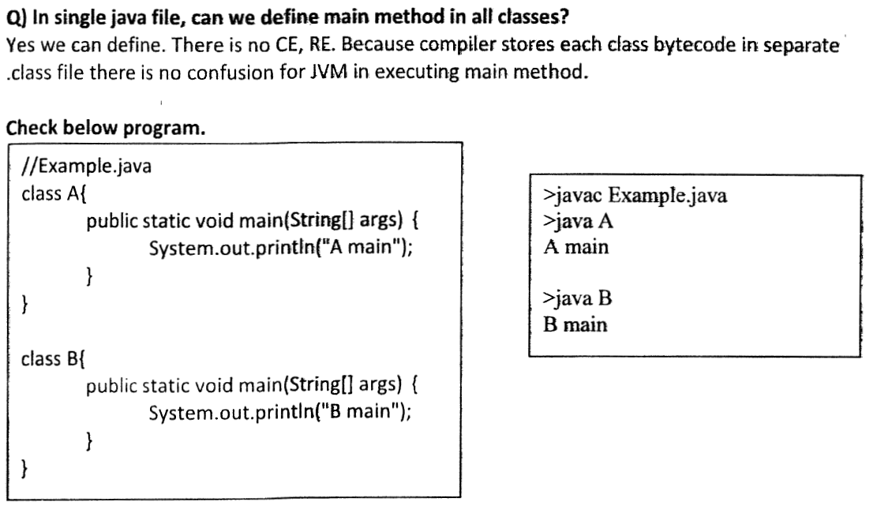

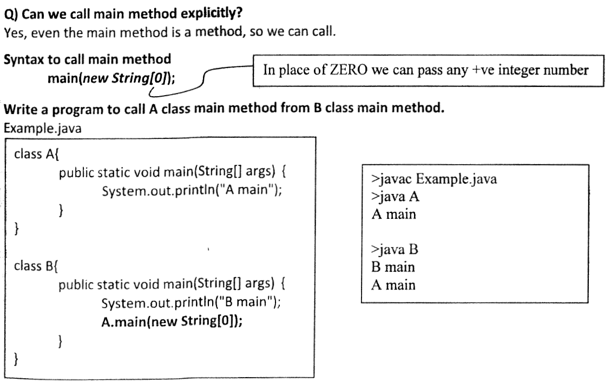

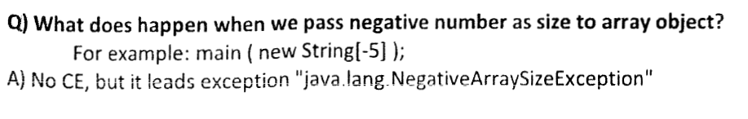

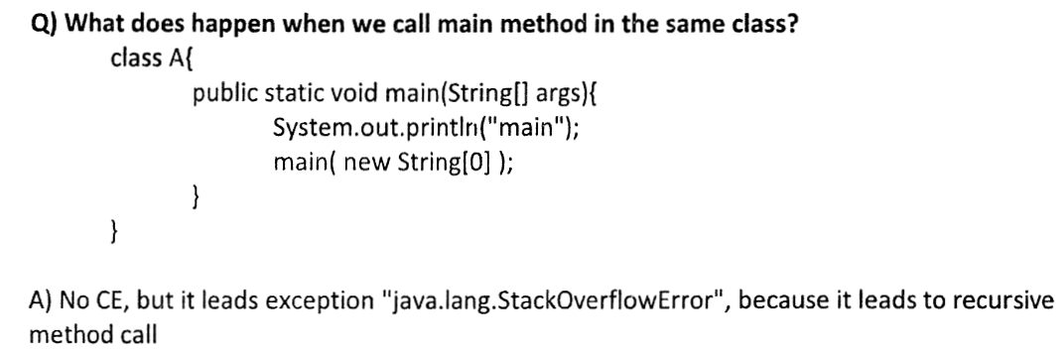

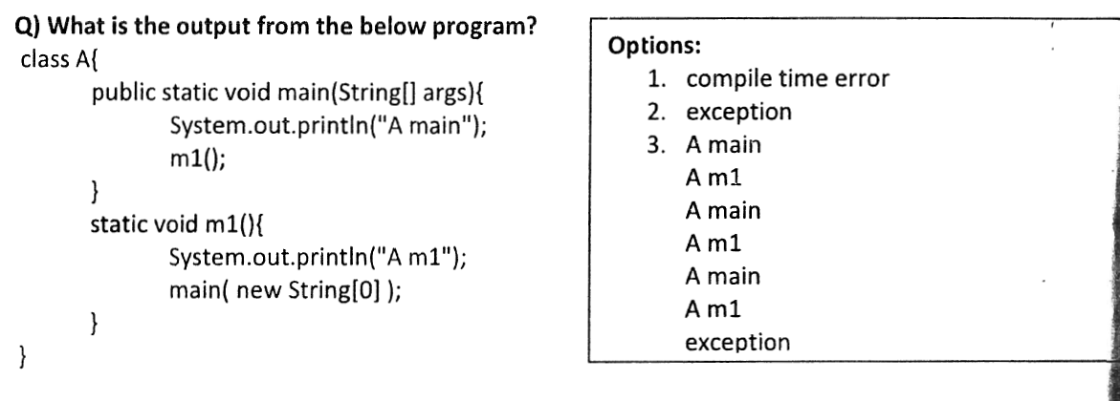

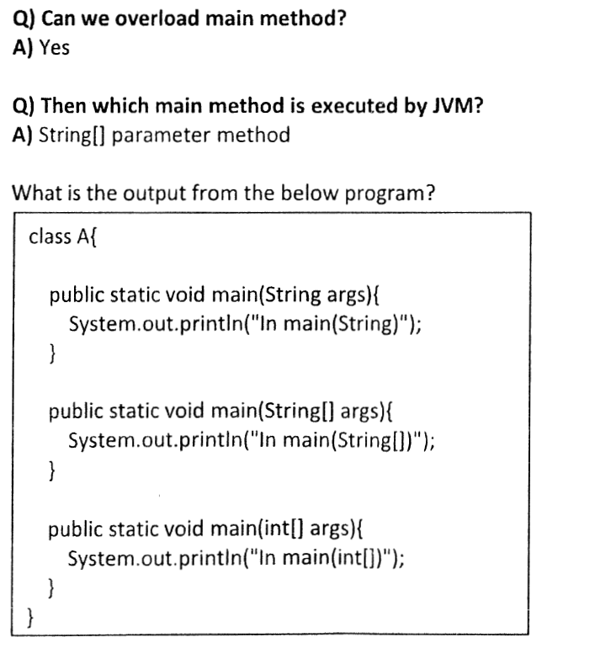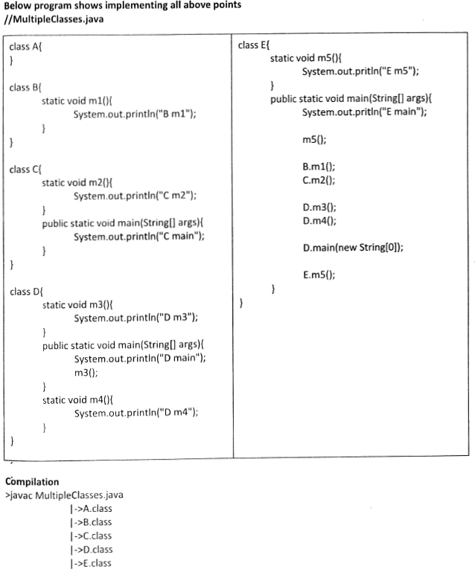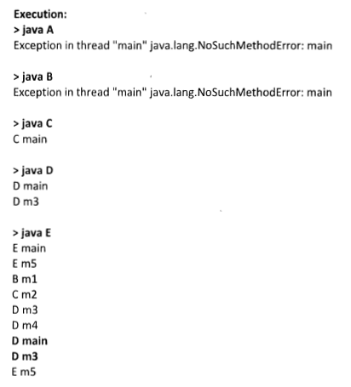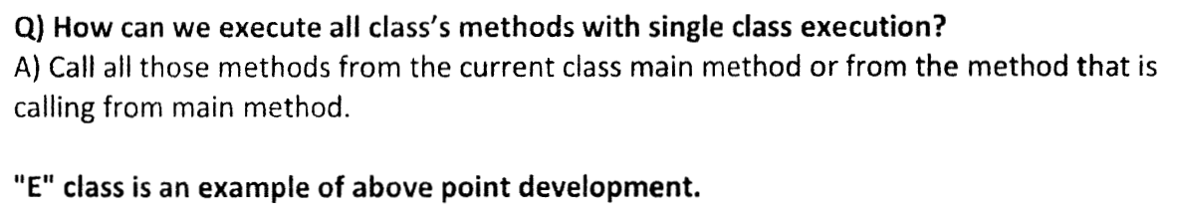

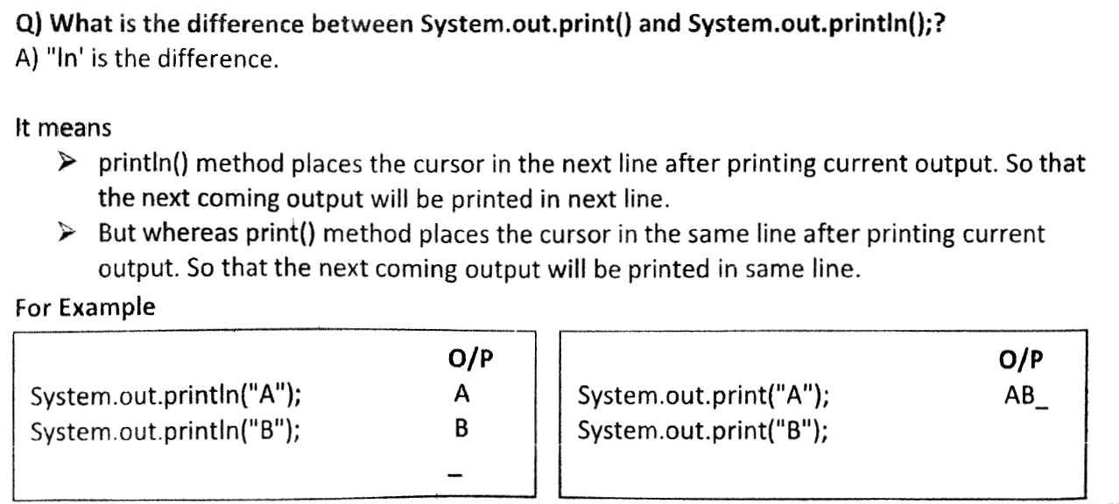

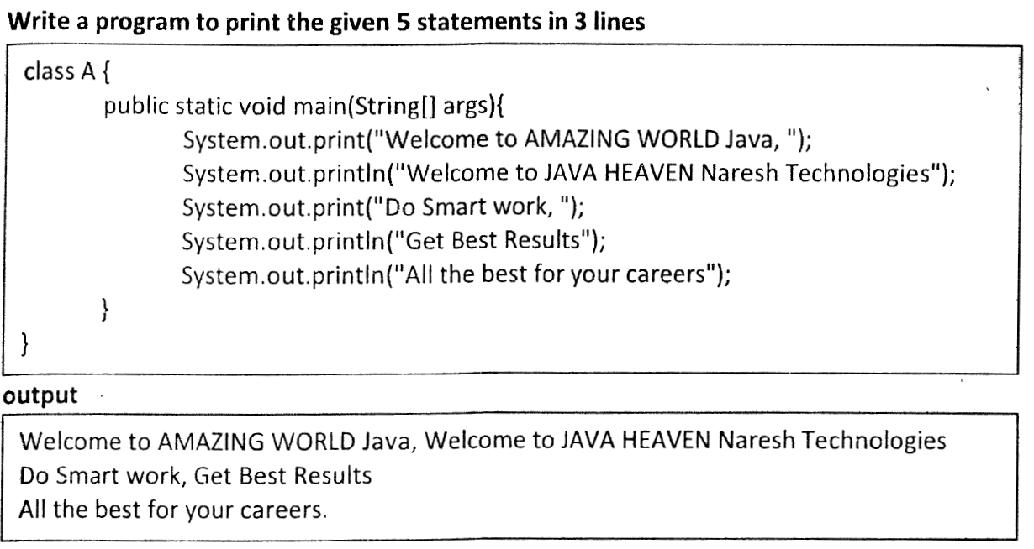

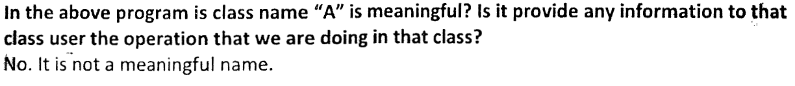

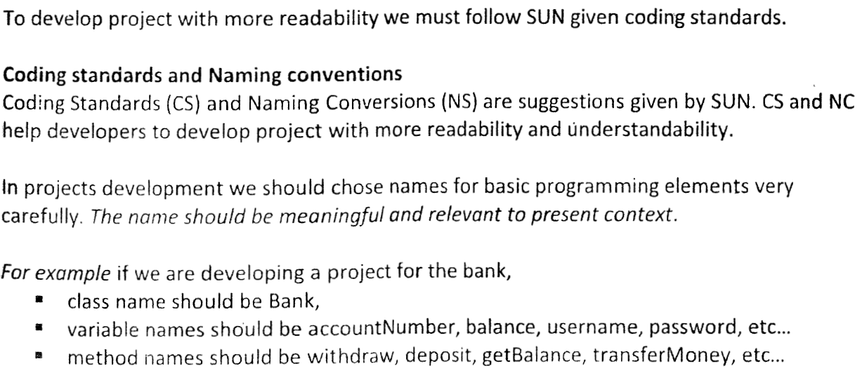

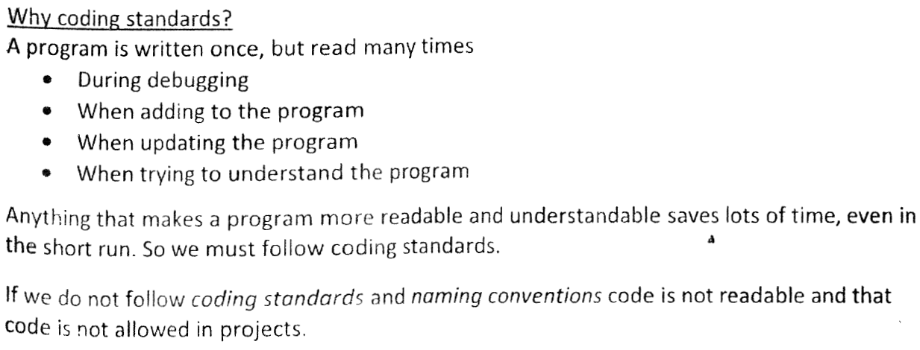

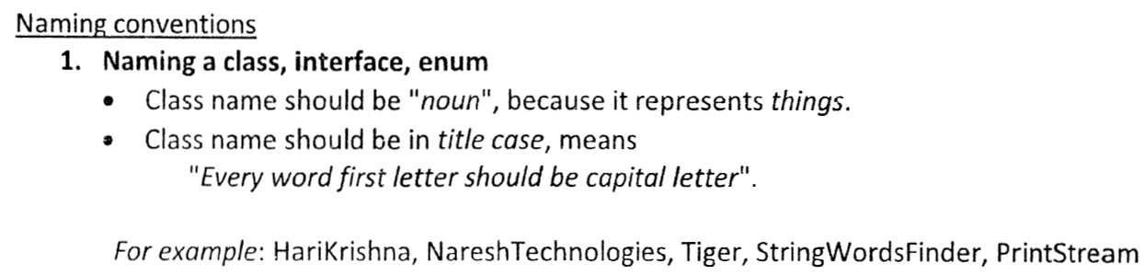

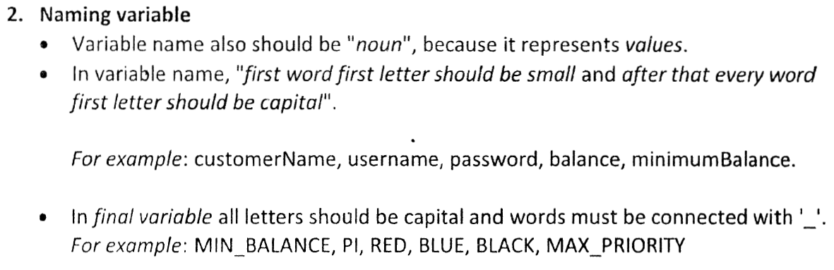

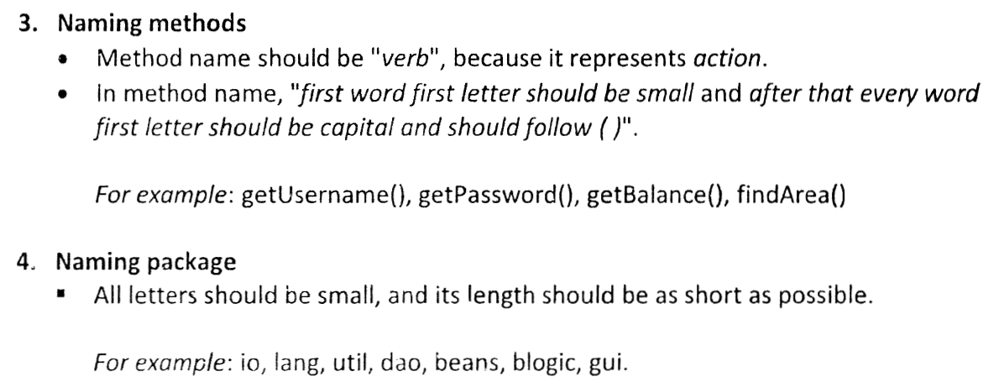

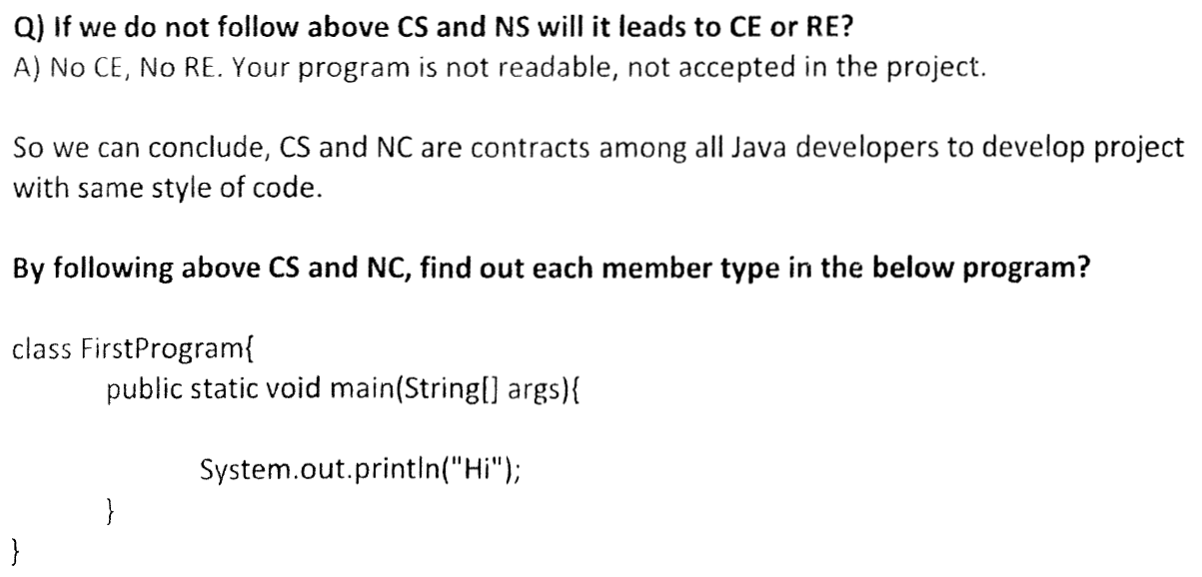

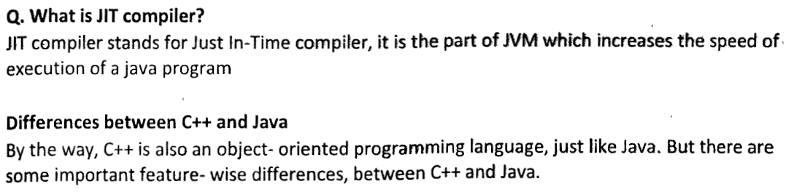

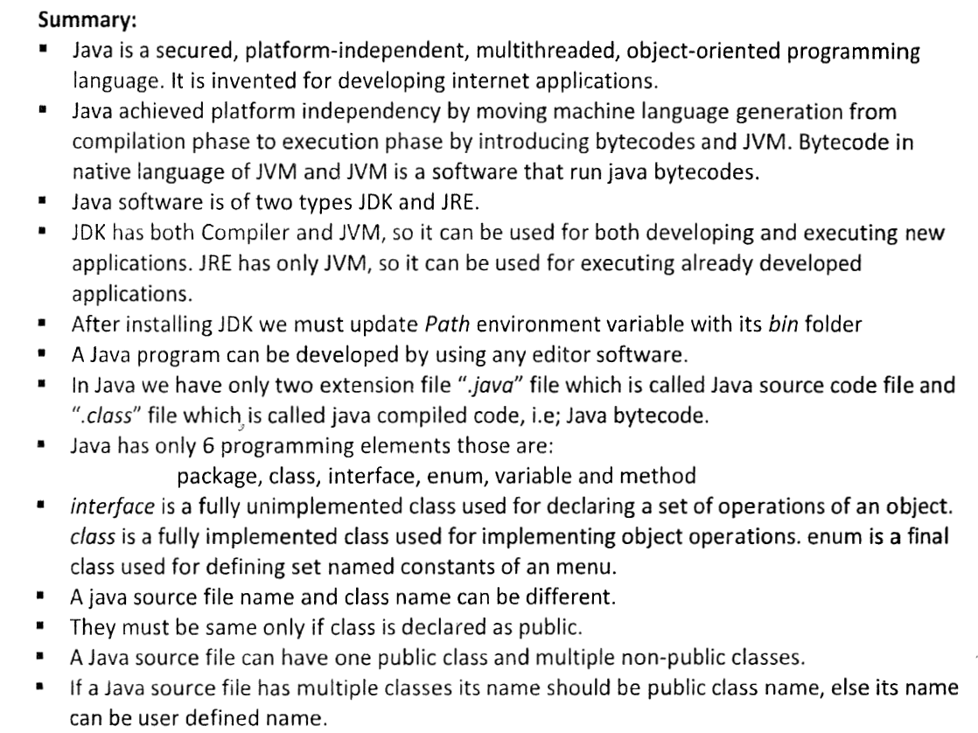

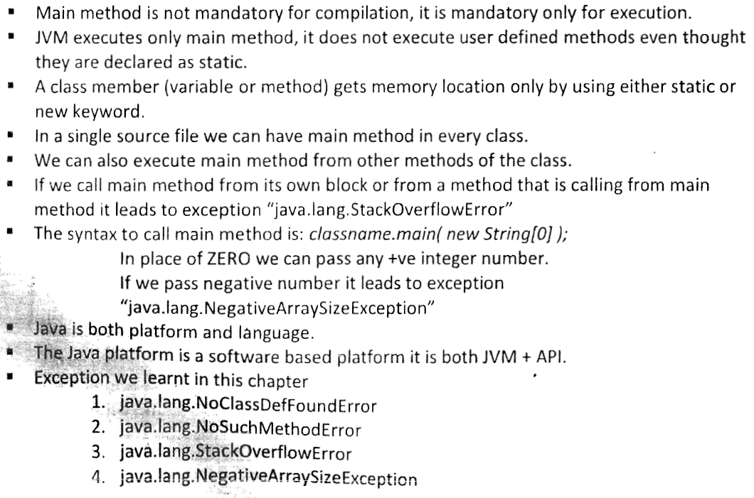

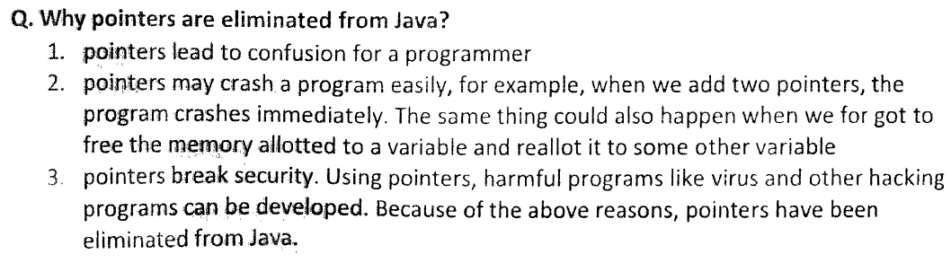

|  |
| --- |
| **What are the basic features of java?**  **The basic features of java are given below :**  - Java is simple. - Java provides immense security. - Java provides high portability. - Java provides object oriented programming features. - Java provides robustness. - Java is multithreaded. - Java provides architecture neutrality.  - Java is distributed. - Java is dynamic. |
| **How java becomes object oriented?**  - Java follows the paradigm of OO programming. - Java follows modular approach. - Java follows the abstraction aspect. - Java follows the OO principle encapsulation. - Java follows the OO principle polymorphism. - Java follows the OO principle inheritance. |
| **How java becomes robust?**  - Java provides multi-platformed environment. - Java provides high reliability in the design. - Java is a strictly typed language. - Java checks the code at runtime. - Java provides predictablity. - java provides various keywords. |
| **How a Java program compiles?**  - First the source file name must be extended with .java extension. e.g. Myprog.java - Execute the javac compiler. - javac compiler creates a file called Myprog.class i.e. the bytecode version of Myprog.java. - The bytecode is executed by the Java runtime-systems which is called Java Virtual Machine (JVM). - JVM is platform dependent. |
| **What is 'public static void main ( String args[ ] ) ' signifies?**  - The access specifier is the 'public' keyword . - 'static' keyword allows main() to be called without instantiating a particular instance of a class. - 'void' affirms the compiler that no value is returned by main(). - 'main()' method is called at the beginning of a Java program. - 'String args()' tells a parameter named args,which is an instance array of class String. |
| **What 'System.out.println()' signifies?**  - 'System' is a predefined class . - System class gives access to the system. - 'out' is the output stream. - 'println' is printing the line on the console. - This is a console output statement. |
| **What is a variable in Java program?**  - It's a memory location. - The memory location is given some name. - The memory location is being assigned some value. - The value may change of the variable. - The memory location size changes with the type of the variable. |
| **What is JVM?**  - JVM is the acronym stands for 'Java Virtual Machine'. - JVM provides the execution environment. - JVM is not platform independent.. - JVM is the Java run-time system. - JVM is an interpreter of bytecode. - JVM also makes the system secured. |
| **What is bytecode?**  - Bytecode is an instruction set. - Bytecode extends with .class. - 'javac' compiler translates the .java file into .class. - JVM interprets bytecode. - Bytecode facility makes Java platform-independent. - It also confirms security to the Java code. |
| **What is Java applet?**  - Applet is a java program. - It has been designed for transmitting the Java code over the internet. - It is automatically executed by Java-enabled Web Browser. - Applet can respond to the user input. - Applet is dynamically programmed. |

**How is Java source code files named?**

Java source code file takes the name of a public class or interface that is defined by the programmer while coding within the file. Source code file may contain maximum one public class or interface in the file. Two cases me occur while naming of the java source code file:  
  
- When public class or interface is defined within a source code file then the java source code file must take the name of the public class or interface defined while coding.  
  
- When no public class or interface is defined inside a source code file, then the java source code file take a name that is different than its classes and interfaces. Source code files use the .java extension.

|  |
| --- |
| **Describe java's security model.**  The Java security model was introduced in Java 2. It is divided into two pieces:  - **User Adjustable Security Manager**: checks various API operations like file access - **Byte Code Verifier**: that asserts the validity of compiled byte code.  Public abstract class SecurityManager java.lang. SecurityManager is an abstract class which helps to different applications subclass to implement a particular security policy. It allows an application to determine whether or not a particular operation will generate a security exception. |
| **What is Race condition?**  **Race Condition**: It is the situation when two threads raise the request for the same resource allocation, but the manner in which resources are allocated are significant, is called race conditions.  - Race condition is created in program in order to run the parallel execution of program by using multiple threads in a same period. - A race condition occurs when two threads operate on same object without proper synchronization and there operation interleaves on each other. - The risk of Race condition is higher in Java. |

**Number the bits, used to represent Unicode, ASCII, UTF-16, and UTF-8 characters?**

- Unicode requires 16 bits  
  
- ASCII require 7 bits. but it is usually represented as 8 bits.  
  
- UTF-8 represents characters using 8, 16, and 18 bit patterns.  
  
- UTF-16 uses 16-bit and larger bit patterns.

**Define reflection**  
- Reflection allows program related access to information about the fields, methods and constructors of loaded classes  
  
- It use reflected fields, methods, and constructors  
  
- It helps to operate on their underlying counterparts on objects,  
  
- It operates within security restrictions.

**Differentiate between JDK, JRE & JVM**

- **JDK** stands for Java Development Kit.  
It is the most widely used Java Software Development Kit.  
  
- **JRE** stands for Java Runtime Environment  
It is an implementation of the Java Virtual Machine which executes Java programs  
  
- **JVM** stands for Java Virtual Machine  
It is an interpreter.

**In Java, how can you send program messages on the system console, but error messages to a file?**

- The class System has a variable out that denotes the standard output,  
- The standard error device represents the variable err .  
- Naturally, they both point at the system console.  
  
In this way, the standard output can be sent to the file:

Stream x = new Stream(new FileOutputStream("error.txt"));  
System.setErr(x);  
System.Out(x);

**What is a native method?**

A native method is a method which is implemented in a non-java language that is targeted for a single machine type. Native methods can pass or return Java objects. To implement the native method, the keyword native is used. The implementation is in another language such as C or C++.  
  
To compile the program which has native method, the following is used:

*javac -jni Premium*

1. **What is the most important feature of java?**

* Java is platform independent language.

1. **What do you mean by Platform Independence?**

* Platform Independence you can run and compile program in one platform and can execute in any other platform.

1. **What is JVM (Java Virtual Machine)?**

* JVM is Java Virtual Machine which is a run time Environment for the compiled java class.

1. **What is JIT Compiler?**

* Just-In-Time (JIT) compiler is used to improve the performance. JIT compiles parts of the byte code that have similar functionality at the same time.

1. **Are JVM's Platform Independent?**

* JVM'S are not platform Independent. JVM'S are platform Specific.

1. **What if main method declared as private?**

* No, It will compile fine but in run time it will error like main method should be in public. cannot find main method.

**7. What is platform?**

* A platform is basically the hardware or software environment in which a program runs.
* There are two types of platforms software and hardware.
* Java provides software-based platform.

**8. What all memory areas are allocated by JVM?**

* Heap, Stack, Program Counter Register and Native Method Stack

**9. What is the base class of all classes?**

* java.lang.Object

**10. What is javac ?**

* It produces the java byte code from *.java file.
* It is the intermediate representation of your source code that contains instructions.

**11. Can we mark constructors final?**

* No, Constructor cannot be declared final.

**12. What are two different ways to call garbage collector?**

* System.gc() OR Runtime.getRuntime().gc().

**13. Can we override a static method?**

* No, we cannot override a static method. Static means class level.

**14. Use of finalize() method in java?**

* finalize() method is used to free the allocated resource.

**15. Is it possible to overload main() method of a class?**

* Yes, we can overload main() method as well.
* But every time public static main(String[] args) will be called automatically by JVM.
* Other methods need to call explicitly.

**16. Does Java support operator overloading?**

* Operator overloading is not supported in Java.

**17. Can I declare a data type inside loop in java?**

* Any Data type declaration should not be inside the loop. Its possible but not recommended.

**18. List two java ID Es?**

* 1.Eclipse, 2.Net beans and 3.IntelliJ

**19. Can we inherit the constructors?**

* No, we cannot inherit constructors.
* We can call super class constructors from subclass constructor by using super() call.

**20. Can this keyword be assigned null value?**

* No, this keyword cannot have null values assigned to it.

**What are PATH and CLASSPATH?**

* PATH and CLASSPATH are two environment variables which need to be set in order to compile and run the java programs.

**Note**:

* The Java interpreter Executes Java application **Byte Codes directly from class files**.
* Appletviewer is used to interpret and execute Java Applet Classes hosted by HTML.
* HTML based Java Documentary help can be accessed using Javadoc.
* javac -verbose TestExample.java – is used to see the details of the compilation
* Nesting of multiple line comment is not allowed

/*

  /* comment 1 */  
 comment 2 */

* This is allowed : // /* Nesting Of Comment */
* Basic aim of java was to solve the problem of connecting many household machines together.
* As there was another language called Oak , they decided to rename OAK. New name was given to OAK
* May 27, 1995- Java was publicly released.
* After first public release java was targeted at Internet development.
* Applet was having early support from Netscape Communications.
* Compiler converts human readable file into platform independent code file in Java.
* Source Code is considered as platform independent code.
* Can we run same java program on different environment with same JDK Version?
  1. We need different JVM because JVM is different for different OS. JVM understands the compiled code.